Frequency Tables
Table 1:
Put these 30 test scores out of 10 into the frequency table below:
3 | 5 | 6 | 3 | 1 | 5 | 5 | 7 | 8 | 1
9 | 7 | 7 | 4 | 3 | 3 | 3 | 2 | 10 | 2
6 | 5 | 5 | 10 | 2 | 5 | 4 | 8 | 3 | 3

Test Score | Tally | Frequency
0
1
2
3
4
5
6
7
8
9
10

Calculate the mean, mode and median:

Make a graph for the frequency table below:
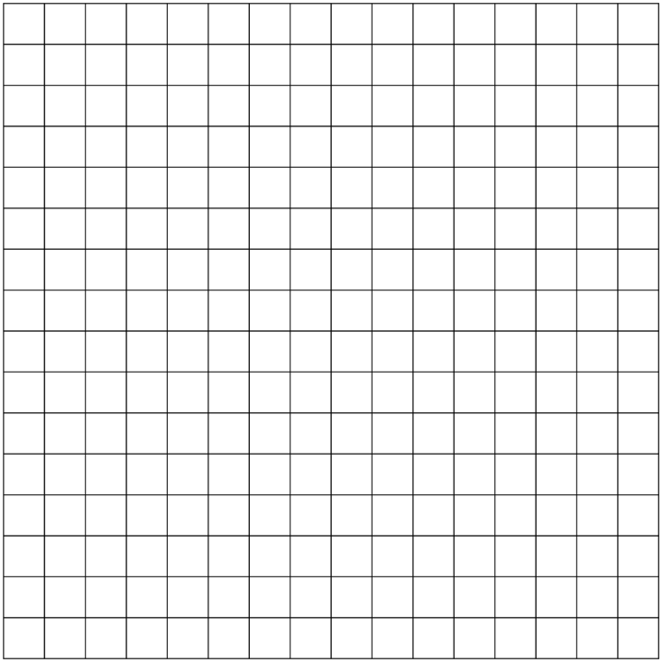
F
R
E
Q
U
E
N
C
Y

Table 2:
Put the results of a survey regarding favourite pets into a frequency table.
Dog | Cat | Dog | Cat | Dog | Dog | Fish | Fish
Dog | Dog | Cat | Cat | Rabbit | Gerbil | Gerbil | Dog
Cat | Dog | Fish | Dog | Snake | Cat | Rabbit | Cat

Pet | Tally | Frequency

Make a graph for the frequency table below:



